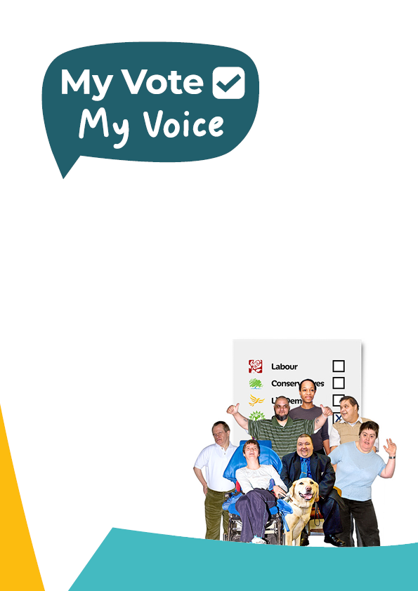

**Come to our Register to Vote Party**

|  |  |
| --- | --- |
|  | We’re hosting a party to help people register to vote. |
|  | It is on: [day and date] at: [time] |
| **Party** | It is taking place at this address:  [address] |
|  | Please tell us if you would like to come. |
|  | [insert details about who to book a place with] |
|  | If you are already registered to vote, you can come too. |
|  | You could help other people register to vote. |
|  | Everybody is welcome to celebrate democracy. |

|  |  |
| --- | --- |
|  | [Please use this page to include information about your party, such as food, decorations, activities, music, who is going, etc.] |
|  | [info] |
|  | [info] |
|  | [info] |
|  | [info] |
|  | [info] |
|  | [info] |
|  | [info] |

|  |  |
| --- | --- |
|  | We are hosting this party because there is going to be a general election on 4th July 2024. |
|  | A general election is when people decide who should run the country. |
|  | You can vote in the general election. |
|  | But you must register first. |
|  | You must register to vote before midnight on 18th June. |
|  | Registering to vote does not mean you have to vote. |
|  | But it makes sure you can, if you choose to. |
|  | By registering to vote you are also showing the government that you have a voice. |

|  |  |
| --- | --- |
|  | **Information you will need so you can register to vote** |
|  | Your full name. |
|  | Your date of birth. |
|  | Your nationality  (This is the country you were born in). |
|  | Your address  (This is important because you need to register to vote each time you move house). |
|  | Your National Insurance Number.  (This is on your wage slips or letters about your benefits). |
|  | You can also find it online through:  www.gov.uk/find-national-insurance-number |
|  | Don’t worry, you can still register if you don’t have one. |

|  |  |
| --- | --- |
|  | You can ask someone you trust to find all of these things. |
|  | Bring them with you to the party. |
|  | Someone will help you register using an online form. |
|  | If you want to vote by post you can also apply for that. |
|  | Or, if you want to vote by proxy you can also apply for that. (This is when someone else votes in person for you). |
|  | If you want to vote in person you need to check you have the right ID. |
|  | If you don’t, you can apply for a free Voter Authority Certificate to use instead. |
|  | Or you can apply to vote by post, complete the postal vote form and then take that to the polling station in person.  (You don’t need ID for this). |

