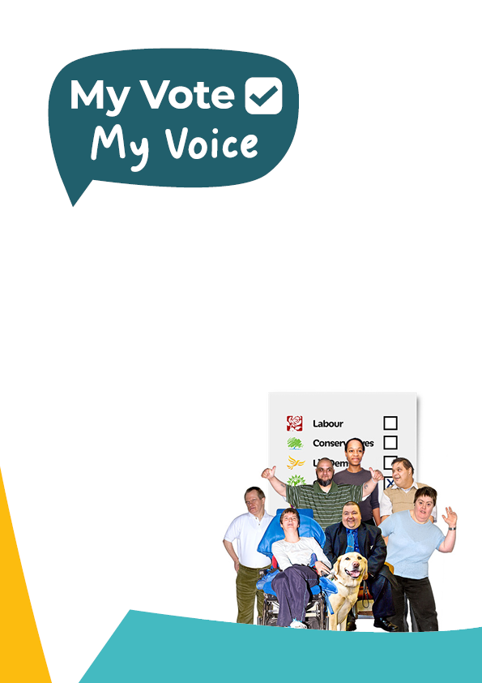

**Your easy read guide to making accessible documents**

|  |  |
| --- | --- |
|  | Easy read is a way of putting information across is an easy to understand way. |
|  | It puts the important information in plain English. |
|  | And has images to help show what it written. |
|  | Sentences should be kept short. |
|  | And addressed to you, the reader. |
|  | Use simple words. |
|  | But if a **difficult word** is needed put it in bold. |
|  | And use the next box to explain what the **difficult word** means. |

|  |  |
| --- | --- |
|   **Don’t** | Only use full names and phrases. |
|  | Such as Houses of Parliament instead of HoP. |
|   **Do not** | And ‘Do not’ instead of ‘Don’t’. |
|   **One** | Use numbers not words. |
|   **1** | Such as ’1’ instead of ‘one’. |
|  | And try not to use big numbers. |
|   **Many** | Instead, say ‘many’, ‘few’ or ‘most’. |
|  | And write the date as day (number) and Month. |

|  |  |
| --- | --- |
|  | For example, the general election is on 4 July 2024. |
|   **: * !**  **# % ~** | Tips for punctuation:   * Use capitals to start a sentence or names only. * Don’t use colons semi-colons or hyphens. * Commas and full stops are ok. * But don’t use too many. * Use plain bullets for lists. * But try not to make lists too long. |
|   **Can**  **Help** | Use positive language. |
|  | For example, say ‘someone can help you fill out this form’  instead of  ‘you do not have to fill out this form on your own’. |
|  | Use one clear image for each sentence. |
|  | And make sure they are copyright free. |
|  | Photosymbols are best if you have an account. |
|  | If you do not, Pixabay has a lot of options. |

|  |  |
| --- | --- |
|  | Easy read documents can look like they are long. |
|  | But they are easier to read. |
|  | And many people prefer them. |
|  | You are being **inclusive** by publishing easy read documents. |
|  | **Inclusive** means you are making sure more people can be involved. |
|  | Especially people with learning disabilities. |
|  | There are lots of easy read documents for you to look at. |
|  | Please visit the My Vote My Voice website for lots more information. |
|  | If you have questions, please email info@myvotemyvoice.org.uk |

